Research document – Luigi’s Mansion 3’s Poltergust

Introduction
For this assignment, I want to recreate the Poltergust from Luigi’s Mansion 3. This is a vacuum cleaner-like device that can be used to capture ghosts, as well as to solve puzzles by sucking up or blowing out air. The world of Luigi’s Mansion 3 is filled with objects that interact with the Poltergust in different ways, thereby creating different gameplay opportunities that revolve around this central mechanic.
My aim is therefore to recreate some of these different level ingredients to actually give the Poltergust something to interact with and to build a demo level with these level ingredients to show off the potential for puzzles that can be made with them.
I will therefore guide my research around the functionality of the Poltergust’s vacuum system in Luigi’s Mansion 3 and the different level ingredients that interact with it in order to find out which of them would be best for me to focus my efforts on to recreate them. To be clear, I am focusing on the vacuum system of the Poltergust, as in its functions of blowing out and sucking up air; in the game, the Poltergust comes with several other features too but those are beyond the scope of this assignment.

Research question
Because my project focuses not only on the Poltergust itself but also on its related LD ingredients, I have devised the following two research questions:
- How does the Poltergust's vacuum system in Luigi's Mansion 3 work?
- What level ingredients does the Poltergust's vacuum system interact with and how?

Data
Research question 1: How does the Poltergust’s vacuum system in Luigi’s Mansion 3 work?
Character & Controls
The input table below shows all the inputs related to the Poltergust’s vacuum system and their outcomes in Luigi’s Mansion 3 during normal gameplay, giving an overview of both the character’s abilities and the related controls.
Input | Description of outcome
 | Luigi walks in direction of stick. Starts running after approximately 2.5 seconds.
 / Motion controls | Luigi looks around / up and down in direction of the stick. The sideways direction is always relative to Luigi, so if Luigi is looking at the camera and the player pushes the stick to the right, Luigi will turn to his right / the player’s left. The minimum & maximum angles of looking down and up are about -30° & 30° with Luigi looking straight forward being 0°.  Motion controls can only be used to aim vertically and only when the player is vacuuming, blowing, carrying an object or holding down the input for the Strobulb, Dark-Light or Suction Shot.
 | Vacuum with the Poltergust as long as the player holds the button down. Can still move around and aim while doing so.  The range of the blowing area has a cone shape and the visual effect extends about 4 Luigis in front of Luigi. However, the effective range of it is larger by about 50%, as objects further away from the visual effect are still affected by the blowing. The closer objects are, the more they are affected by the blowing, as the force decreases over distance.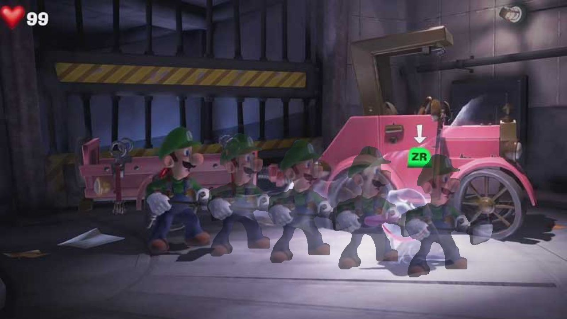
 | Blow with the Poltergust as long as the player holds the button down. Can still move around and aim while doing so. The same rules regarding range and effectiveness as for the vacuuming apply here as well.
/ | Makes Luigi switch from blowing to vacuuming or from vacuuming to blowing, even if the player continues to hold down the first button.
 | Burst: creates a burst with the Poltergust, making Luigi jump in the air to about 2/3 his own height for about 1 second total. The burst also sends out a shockwave that can push away objects and enemies. If the player continues to hold the buttons down after the burst has completed, Luigi will start vacuuming.

Camera
Lastly, to get give a complete context to how the Poltergust works in the game, it is necessary to examine the camera. The camera angle in Luigi’s Mansion is mostly fixed, save for specific events and boss fights and the player has no direct control over it. It only zooms in and out and occasionally moves slightly depending on the surrounding geometry. Any walls that would obscure the camera’s view from Luigi will be rendered transparently to prevent this.
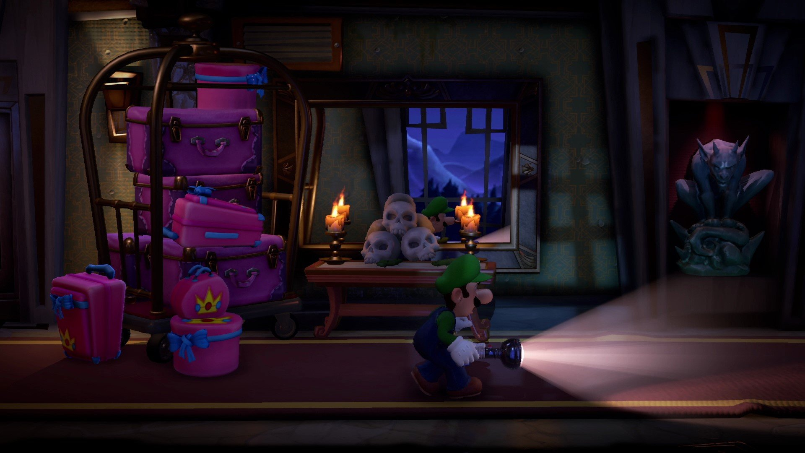
The screenshot above illustrates the camera angle throughout most of Luigi’s Mansion 3

Research question 2: What level ingredients does the Poltergust's vacuum system interact with and how?
The table below gives and overview of the different level ingredients I found that interact with the Poltergust’s vacuum system and how. There are many objects that behave in slightly different ways, so each row contains a category of objects, which are grouped together under broader categories highlighted in orange. I also included an indication of whether or not the ingredient uses physics as far as I could find this out, as it is valuable information to figure out how it works and how it could be remade.

Level ingredient | Description | Screenshot
VACUUMABLE OBJECTS
These are small objects that are simply pushed around by blowing on them or vacuumed up.
Vacuumable objects | All sorts of objects scattered around the world can be sucked up, effectively destroying them. Most are purely decorative, but it also includes money, which Luigi can collect this way.  USES PHYSICS: YES | 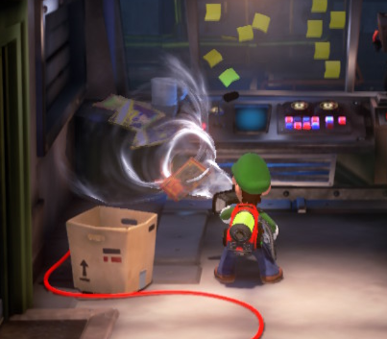
Sand | Can be vacuumed up similar to vacuumable objects, revealing hidden objects underneath or clearing a path, but can also be pilled up by blowing on it to reach otherwise inaccessible areas.  USES PHYSICS: YES | 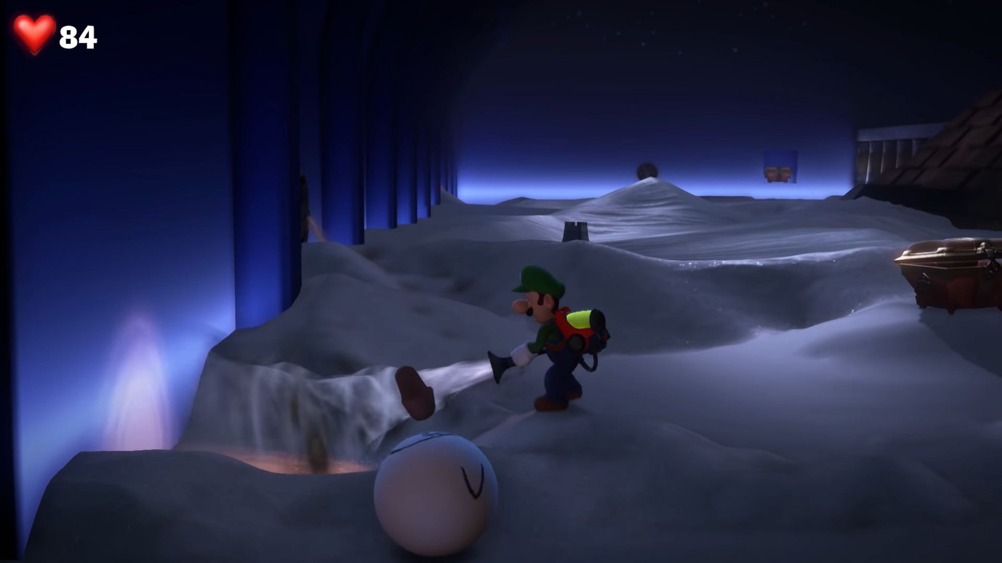
GRABBABLE OBJECTS
These objects can be “grabbed” by vacuuming on them, allowing Luigi to interact with them in different ways.
Flexible objects | These include things like tarps, tapestries and leaves that cover objects or hidden openings in walls but can also be purely decorative. Luigi can vacuum them by a specific point to “grab” them with the Poltergust and walk back to create tension. This brings up a prompt to press the A button and fills a meter around the button up the further Luigi walks back, which is limited until the fabric is at its maximum tension. If the player continues to push the stick away from the object, they can then press A to suck the cloth up. The player cannot aim while grabbing an object and will let go of the object if they release the ZR button or press the ZL button.  USES PHYSICS: YES | 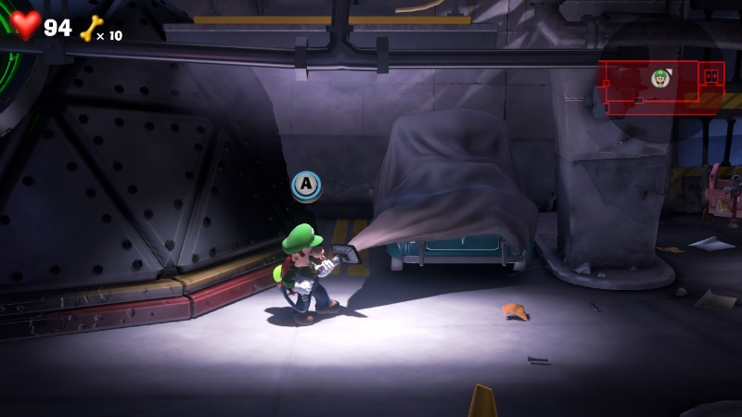
Pullable objects | These work similarly to vacuumable cloths, in that the player can vacuum on a specific point to grab them, then walk back, press A and vacuum them up, destroying the object, usually to clear the way. The difference is that these objects do not use physics.  USES PHYSICS: NO | 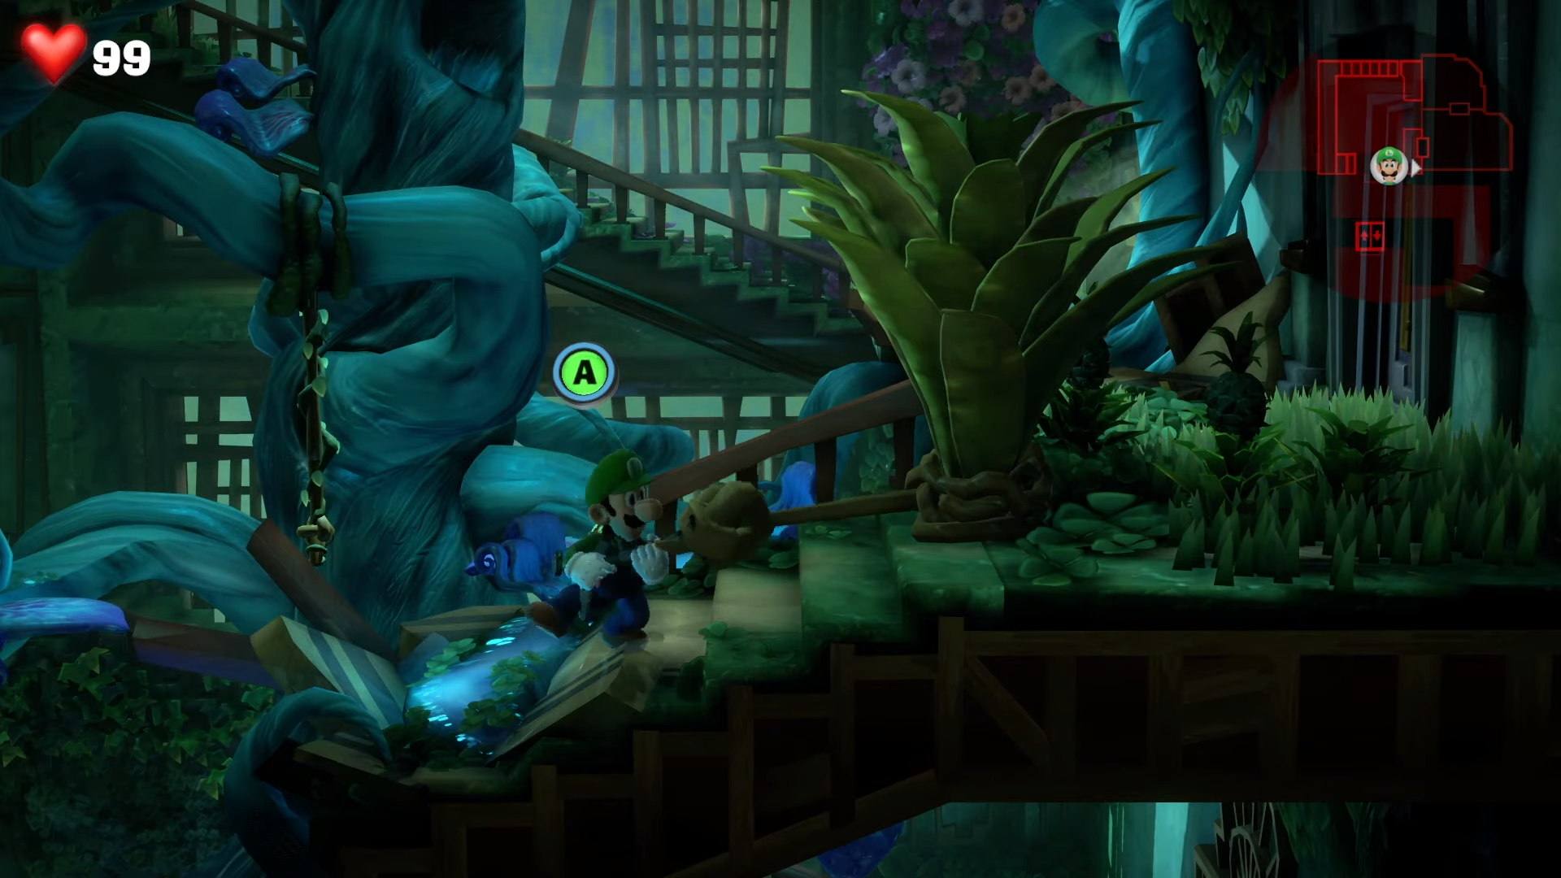
Plungers | Luigi can launch a plunger at certain surfaces using the Suction Shot ability and then pull on it similarly to the objects mentioned above. This way, they can pull down or swing them around, which destroys some objects. The behavior depends on the object.  USES PHYSICS: MAYBE | 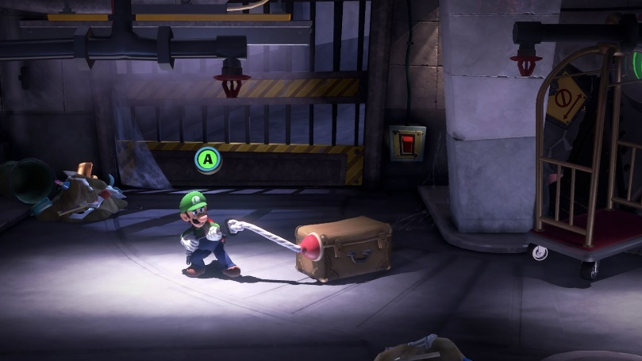
Vines | Vines that hang from the ceiling and can be grabbed by sucking on them. Luigi will then start swinging on the vine. The player can move the left control stick in direction with the swinging of the vine to increase the swinging momentum, or decrease it by moving the stick in the opposite direction. If they do not move the stick at all, the momentum will also decrease until the player hangs still. The player can let go of the vine by pressing ZL or releasing ZR, at which point Luigi will fall, keeping the momentum from the vine swinging.  USES PHYSICS: YES | 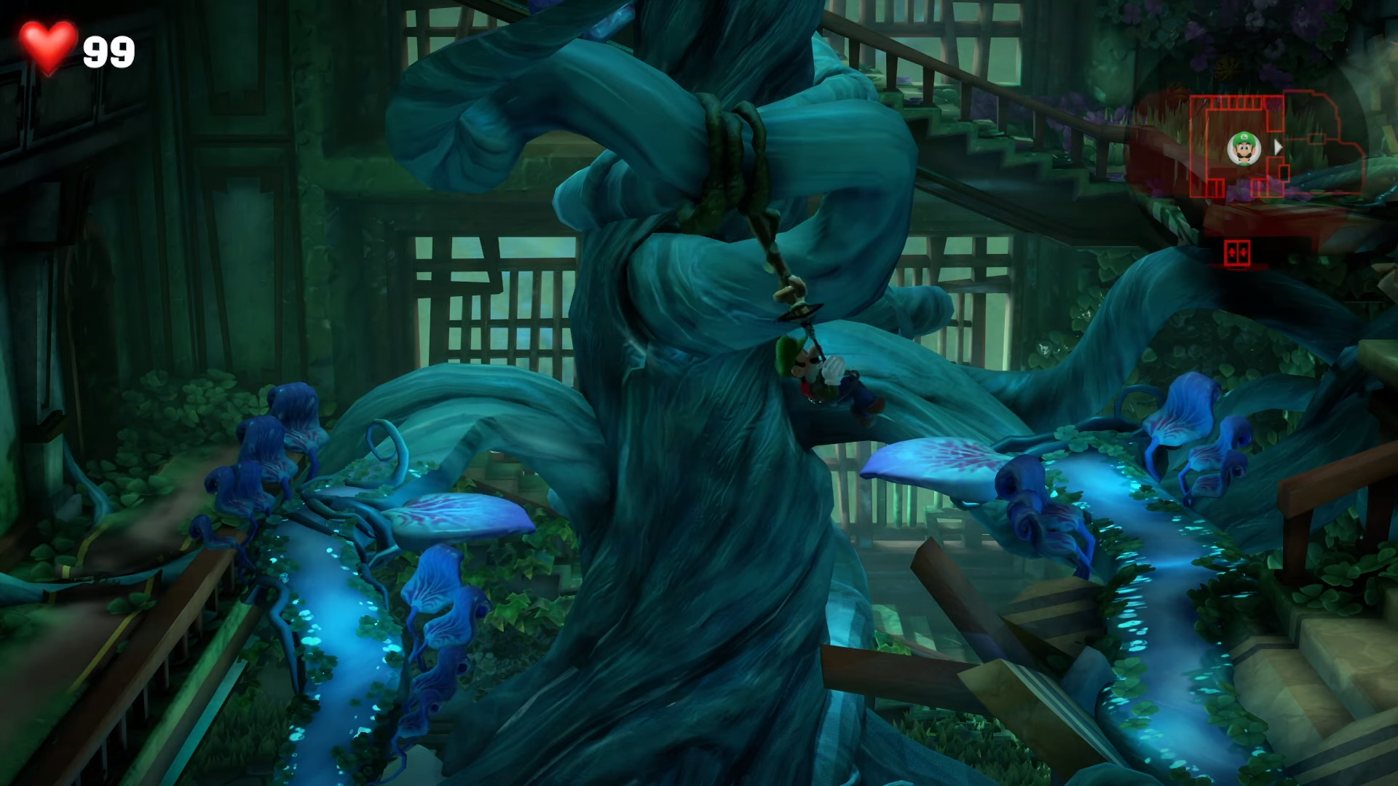
Portable objects | These are larger objects that can be “grabbed” by vacuuming them but will not be sucked up, so Luigi can carry them around. The player does not need to hold down the ZR button while carrying the object; if they let go, Luigi will continue to carry the object. Pressing ZL will cause Luigi to either drop the object or launch it in the direction he is aiming, depending on the object. With launchable objects, an aiming cursor will appear when they are picked up, which will snap to relevant targets. In the screenshot to the right, the player can launch the jack-o-lantern at the portraits hanging from the ceiling.  USES PHYSICS: MAYBE | 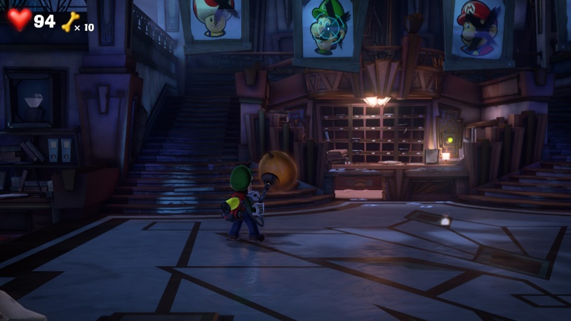
MOVABLE OBJECTS
Objects where the main purpose is to move them around in some way with the Poltergust that cannot be vacuumed up like vacuumable objects.
Rollable objects | Objects like carpets or curled up plants that can be rolled up or out by blowing or sucking on them. Some can be rolled and unrolled as the player wants, but others only go one way.  USES PHYSICS: MAYBE | 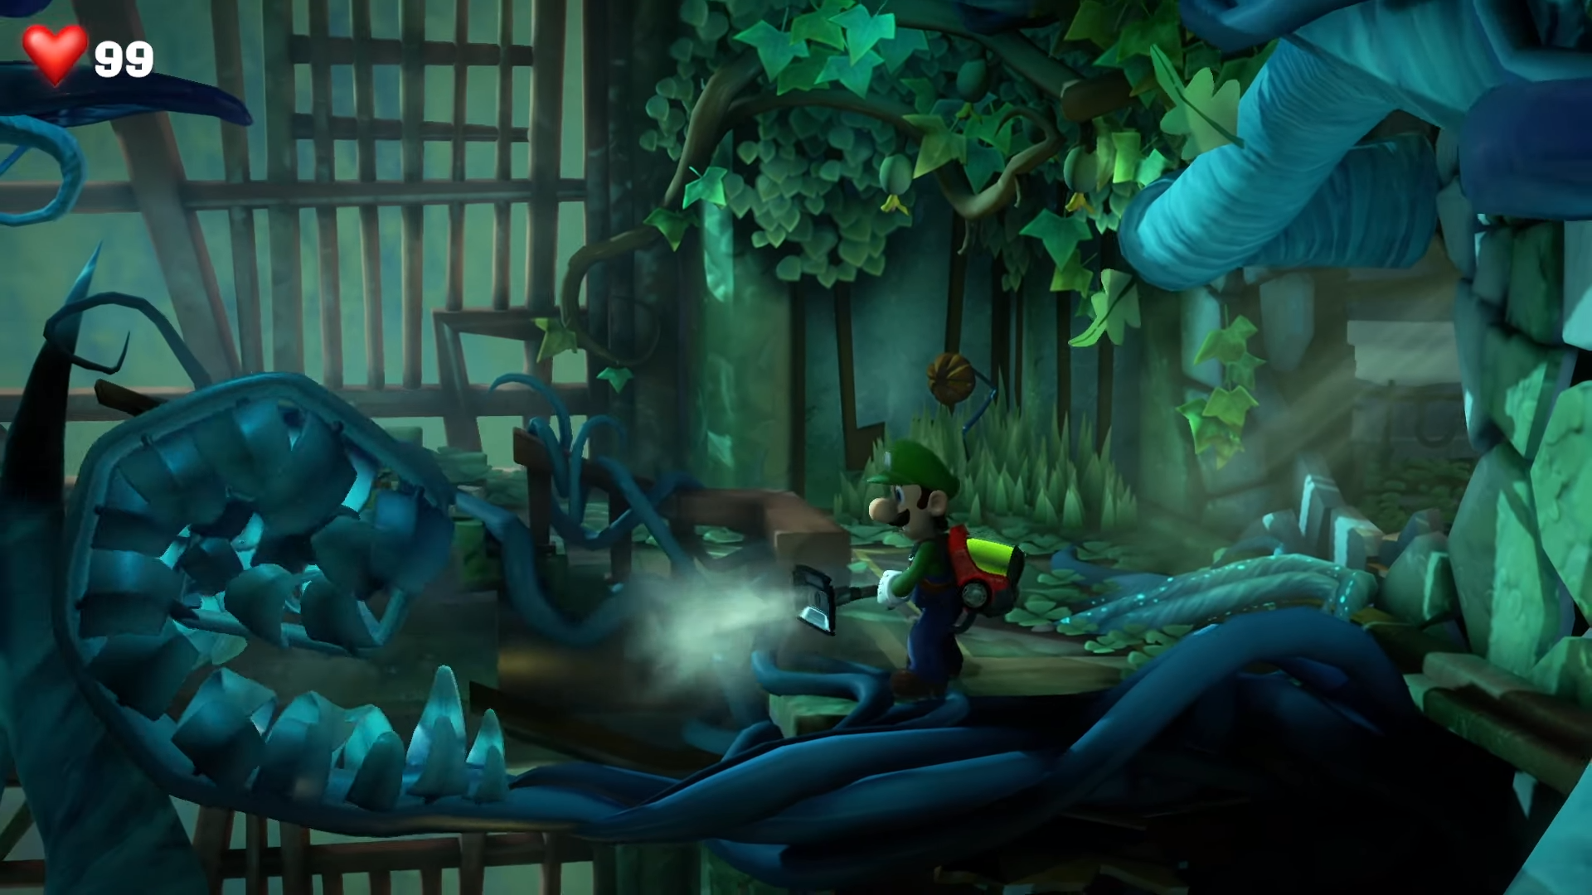
Straight line movable objects | Objects that can be moved only in a straight line (and can’t deviate from this set path) by blowing or sucking on them.  USES PHYSICS: NO | 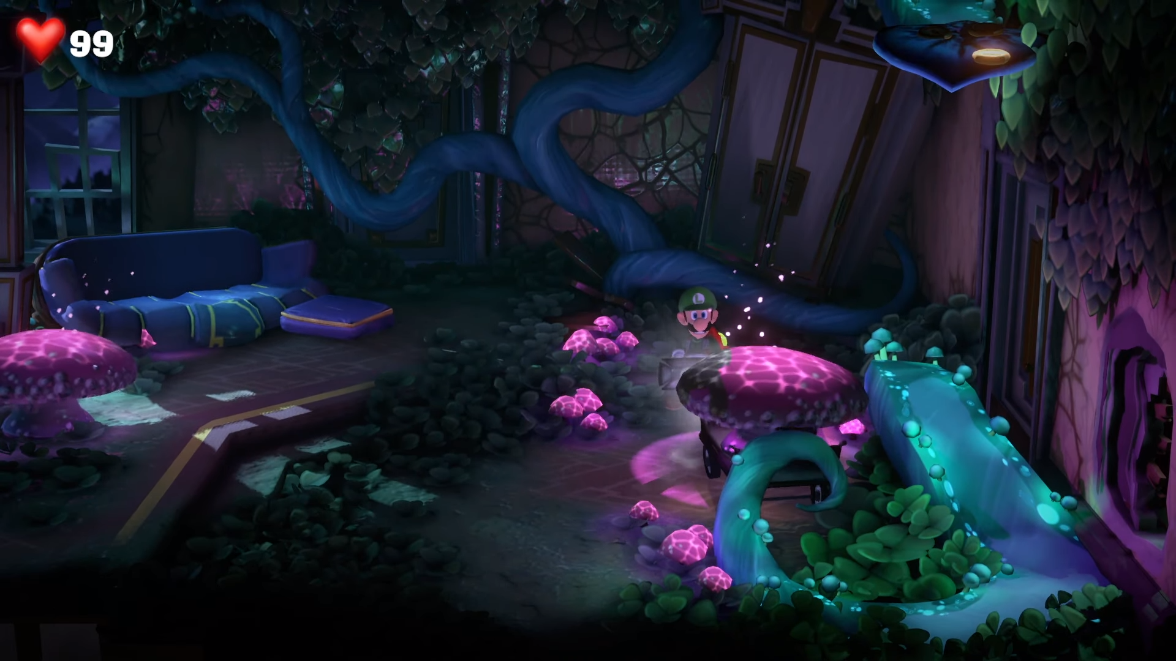
Floats | When Luigi hops on a float, the player can only aim horizontally, not vertically. By blowing, the player will push themselves aways from the direction they are facing and by sucking, they will move themselves in that direction.  USES PHYSICS: YES | 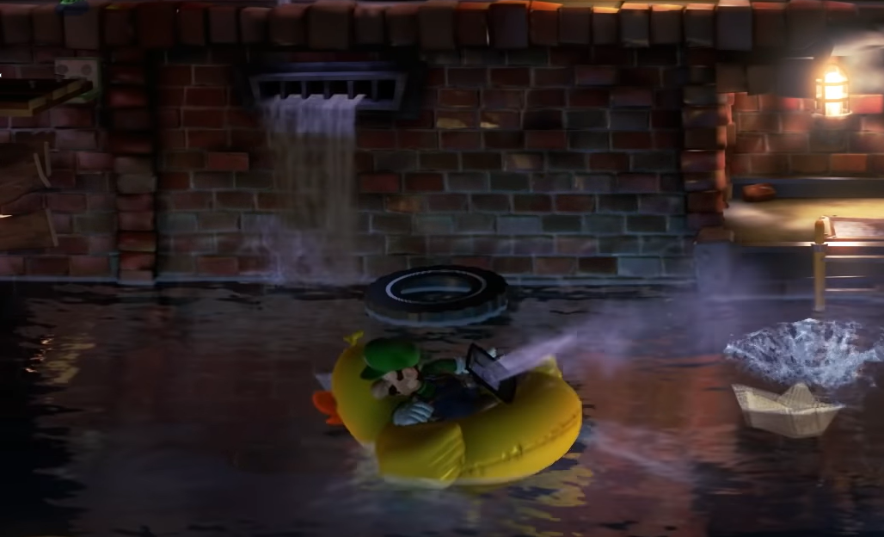
SWITCHES
Switches that are activated by blowing or vacuuming on them, thereby influencing other level ingredients.
Simple switches | These are switches usually in the form of a rope that the player can suck up to pull and activate them. The pulling system works the same as with pullable objects. They often open doors or deactivate traps. Some can only be activated once, others will deactivate when the player lets go, either directly or over some time.  USES PHYSICS: MAYBE | 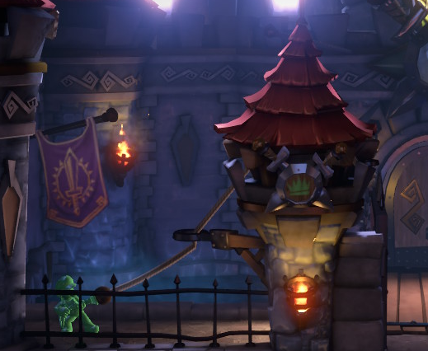
Rotatable switches | These switches usually come in the form of something like a fan, valve or wheel of some kind and can be either vacuumed or blown on to rotate them one way or the other. This can be used to activate or deactivate other objects, or to move them between different positions. In the screenshot to the right, it is used to make the platform in the middle rotate, giving access to different areas.  USES PHYSICS: NO | 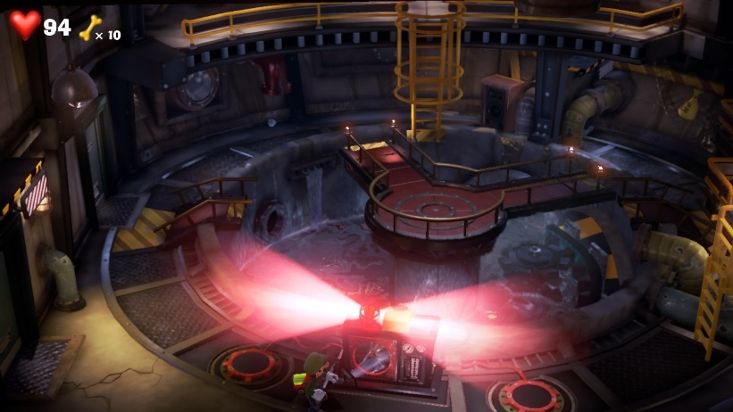
ENEMIES
Enemies that can be defeated with the Poltergust’s vacuuming system.
Ghosts | Ghosts are the main enemies in the game. There are different varieties, but to defeat them, they must usually first be stunned with Luigi’s Strobulb. After this, the player can grab the ghost by vacuuming their tail. The player can grab up to six ghosts at once if they are close enough but once a ghost has been grabbed, they won’t be able to grab another until the first ghost has been released.  Once grabbed, the ghost will try to escape by flying in different directions, pulling Luigi along with them. The player must hold the stick in the opposite direction of the ghost’s movement to slow the ghost down, or the ghost will escape after around 4 seconds.  Successfully holding the stick in the opposite direction will deal around 1 damage per 0.05 seconds to the ghost and will also fill up a meter allowing the player to press the A button and slam the ghost to the ground, instantly dealing 20 points of damage. The player can control the direction in which they slam the ghost with either control stick.  After the player starts slamming, the meter around the A button prompt will start to deplete over the course of around 4 seconds. When it is empty, the ghost will escape if it has any health left, at which point the player will need to capture them again. The player can slam the ghosts into breakable objects to break them or into other ghosts to deal 20 damage to those ghosts as well.  USES PHYSICS: NO | 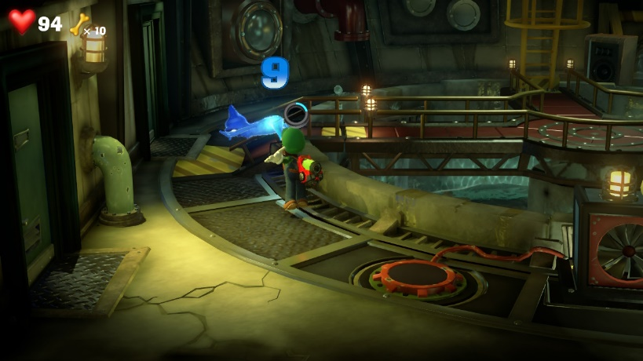  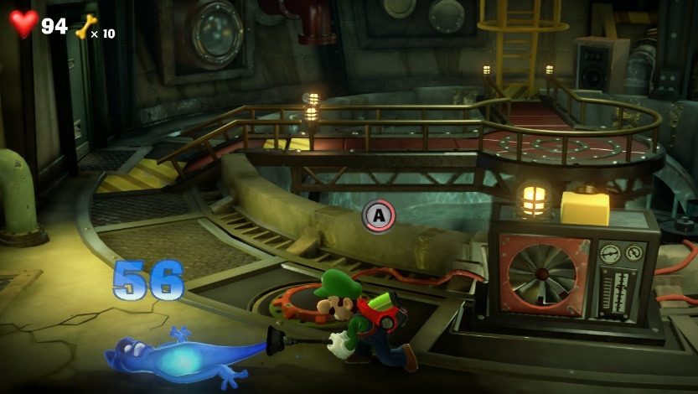
Spirit Balls | These appear when Luigi reveals a hidden object with the Dark-Light, usually 4 or 5 of them. They hover in place for a few seconds and then quickly move to a nearby location but never too far from their origin. The player can simply suck these orbs up and once all are captured, the hidden object will be revealed.  USES PHYSICS: NO | 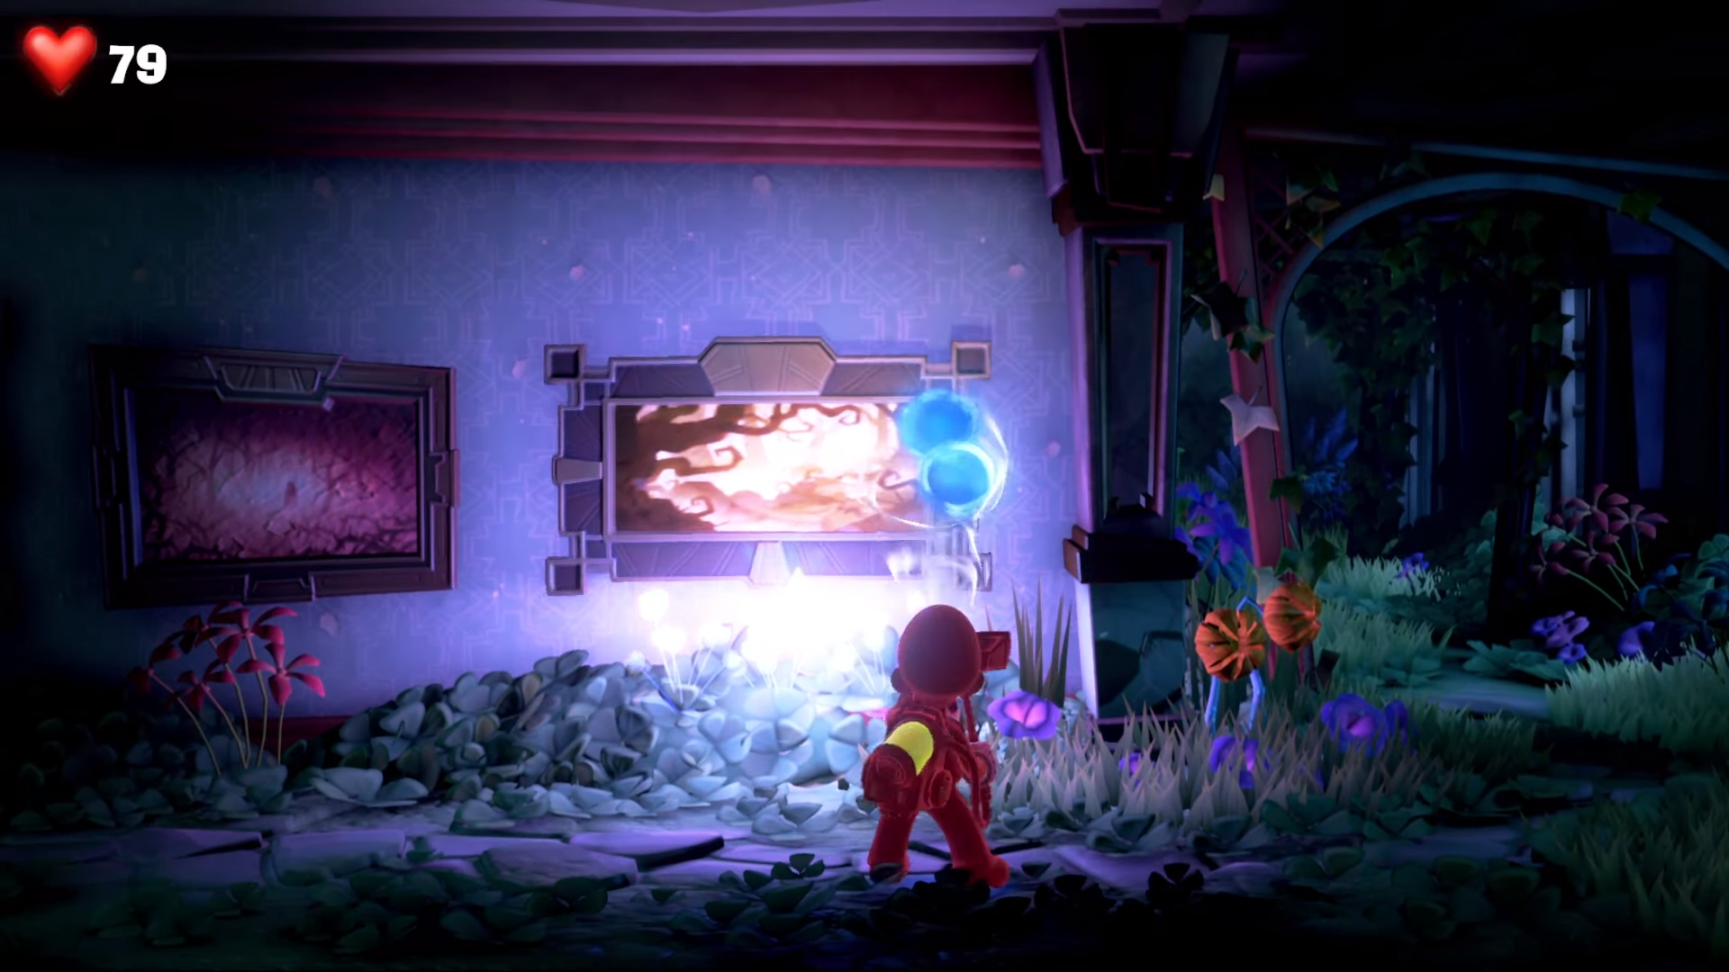
Critters | These are minor enemies like spiders, bats and rats that can damage Luigi and are defeated by either hitting them with the Strobulb or sucking them up.  USES PHYSICS: NO | 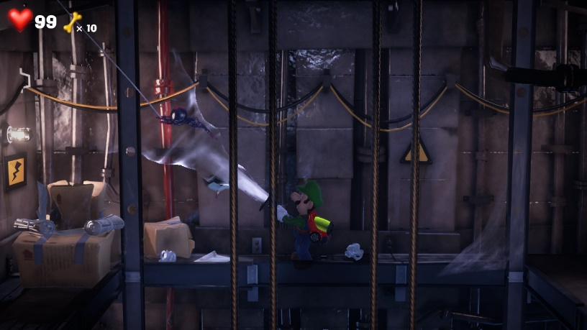

Conclusion
How does the Poltergust’s vacuum system in Luigi’s Mansion 3 work?
The vacuum system itself works by pressing and holding down the ZL / ZR buttons to blow out or suck up air. The player can move with the left stick and aim with the right stick or motion controls while doing so. The effective range of the vacuuming and blowing systems has a cone shape that extends about 6 times the width of Luigi. The suction or blowing force decreases the further the object is. There are many other inputs for abilities that are indirectly related to the vacuum system but these are different systems that I am not aiming to recreate for this project.

What level ingredients does the Poltergust's vacuum system interact with and how?
The Poltergust interacts with many different level ingredients. I identified the following broad categories:
- Vacuumable objects: Can be sucked up with the Poltergust, effectively destroying them.
- Grabbable objects: Can be “grabbed” with the Poltergust by vacuuming on them, allowing Luigi to interact with them in different ways, like pulling the object, carrying it around or swinging on a vine.
- Movable objects: Objects that can be moved in some way using the Poltergust, usually by moving them along a straight line or rolling them up / out.
- Switches: There are two main types of switches that can affect other level ingredients: simple switches that can be activated by vacuuming on them and pulling them and rotatable switches that can be rotated one way or the other by vacuuming or blowing on them.
- Enemies: Different kinds of enemies that can be fought using the Poltergust’s vacuum system.

Takeaways
Now knowing the logic of the Poltergust’s vacuum system, I can recreate the base setup and can approximate some of the more specific details. This way, I can start by recreating the functionality of the system and then try to finetune this to recreate the feeling of the original game as closely as possible once the core functionality is in place. I will also focus on the vacuuming and blowing abilities; the burst ability is something I consider different from the vacuuming ability, as it does not activate LD ingredients in the same way as the vacuuming abilities do.
Based on my research into the level ingredients, I have chosen the following that I would like to remake, ranked in priority from most to least important:
- Simple switches
- Rotatable switches
  - Doors
  - Spike traps
  - Movable platforms
  - Rotating platforms
- Portable objects
  - Hittable switches
- Vacuumable objects
- Ghosts (dummies without AI, just to recreate the capturing mechanic)
- Pullable objects
- Movable objects
- Spirit Balls (if I implement the Dark-Light as well)

The level ingredients marked in green are a minimum goal for me, the ones marked in red are stretch goals. I have chosen these ingredients in this priority because of the value they add to the gameplay and the feeling of the game, as well as how difficult I think they would be to recreate. For instance, the switches are important as they allow for many different puzzles to be made, while the vacuumable objects have very little actual gameplay purpose but add a lot to the identity of the game, as you often go around vacuuming up items. Meanwhile, the ghosts, even without AI would be more of a challenge, as they still need to move around sporadically, but I think they also are a core part of the game’s identity and are a good challenge for me to try my skills, hence why it’s my top stretch goal.
As can be seen, I also added several “sub-ingredients” under the switches and the portable objects, as these ingredients will need something else to interact with. This may seem like a lot of additional ingredients to create, but they are mostly very simple and I will be able to leverage work from previous projects for them.

Sources
https://www.mariowiki.com/
Nintendo Co., LTD. (2019). Luigi’s Mansion 3 [Video game]. Next Level Games.
https://www.youtube.com/watch?v=QIBAnyFbg0Y&t=2059s&ab_channel=Release-Fire
https://www.youtube.com/watch?v=Fh4llHvUkWM&t=557s&ab_channel=underbuffed

